***PAAREES PERFUMES***

***DAVIDOFF***

***FOR UNISEX***

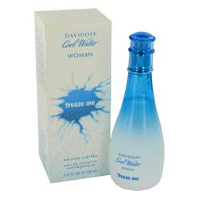

# *Cool Water Freeze Me*

***Description:***

Cool Water Freeze Me by Davidoff Perfume. Before heading to the beach or out on the town with the girls, spray on Cool Water Freeze Me to feel fresh and confident all day long. Introduced in 2008 by the design house of Davidoff, this everyday fragrance for women combines the sweet smell of pineapple with the floral scents of magnolia and violet. It also includes bamboo and jasmine tones, creating an aroma that is flirty, fun and perfect for casual daytime wear.